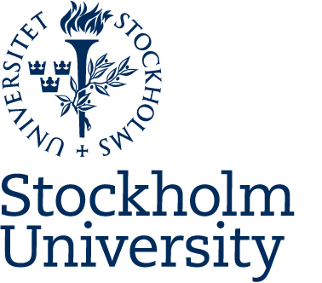

Professional development course 1, Teaching and Learning

Semester: Autumn 2026
Professional development course in higher education teaching and learning. The course aims at supporting the professional development of university teachers from all disciplinary areas at Stockholm University and requires no previous teaching experience or training in higher education teaching. The course corresponds to five weeks full time study, equivalent to 7,5 credits.
Participants who fulfil all course requirements are entitled to a course certificate.
Courses at the Centre for the Advancement of University Teaching (CeUL) are designed to strengthen the basic pedagogical competence required for academic teaching positions. Courses offered by CeUL are aligned with SUHF’s national goals and recommendations regarding teaching competence. The courses are organized in research on higher education pedagogy, as well as collegial exchange of experience.

Aim and intended learning outcomes
Upon completion, participants will be expected to:
- discuss and problematize own conceptions of learning
- plan and evaluate teaching based on higher educational research on the learning of individuals and groups
- communicate and collaborate via digital tools and discuss how these may support learning in higher education
- meet students in an inclusive manner and have knowledge of regulations and available support for students with disabilities
- discuss the conditions for teaching in higher education based on knowledge of relevant national and local regulations as well as societal goals of higher education
- demonstrate a reflective approach to one’s own academic teaching capacity, the relationship with the students and the values of higher education

Content and course activities
The course consists of six obligatory three-hour online seminars plus a choice of three workshops offered by the Centre for Advancement of University Teaching. Between meetings participants read course texts and complete individual and group tasks. Since the main thinking behind the course is the active exchange of experiences between teachers across a range of disciplines, participation in all seminars is compulsory.
The following themes are addressed in the course:
- Research on student learning and the teachers’ role in higher education.
- Educational design.
- Assessment, examination and evaluation.
- Pedagogical reflection and the development of teaching

Obligatory activities and attendance
In order to facilitate engagement with the course curriculum, all sessions require compulsory attendance. We will provide participants with preparation tasks which will help in approaching the central issues on the literature and discussions.
Please note that you are required to attend three workshops (organized by CeUL) as part of the course.
The course examination consists of the following:
- A written reflection on teaching and learning (teaching statement), and peer feedback on one or more other teaching statements.
Participants who complete the course assignments with a passing result will receive a course certificate.
Course assignments are expected to be completed by participants without undue assistance from generative AI.
Participants with disabilities may request adapted course assignments if needed, in consultation with the course coordinator well in advance of the course start.

Literature
Hunt, L. & Chalmers, D. (2021). University Teaching in Focus: A learning-centred approach. 2nd Edition. Routledge.
Online support: Creating a teaching portfolio https://www.su.se/ceul/english/education/teaching-portfolio
Further resources in the form of videos, articles, and book chapters are linked to each seminar and will be presented at the start of the course.

Course leaders
Mara Haslam, Senior lecturer
Department of Teaching and Learning, Stockholm University
John Airey, Professor
Department of Teaching and Learning, Stockholm University
Study guide

